Chapter 14, Solution 46.

- 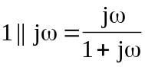, 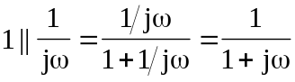

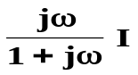
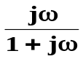
Transform the current source gives the circuit below.
+
−
+
V_{o}
−
1



 